Assignment 1 : Analyze packet capture and analysis
Name : Atish Kadam
Roll Number : CS25MTECH14003

PART-A: Analyze packet trace of your browsing session
1. Which of the following protocols are shown as appearing (i.e., are listed in the
Wireshark “protocol” column) in your trace file: TCP, QUIC, HTTP, DNS, UDP,
TLSv1.2, etc?
Ans-
TCP QUIC HTTP MDNS DNS

2. How long did it take from when the HTTP GET message was sent until the
HTTP OK reply was received? (By default, the value of the Time column in
the packet-listing window is the amount of time, in seconds, since
Wireshark tracing began. (If you want to display the Time field in time-of-
day format, select the Wireshark View pull down menu, then select Time
Display Format, then select Time-of-day.)
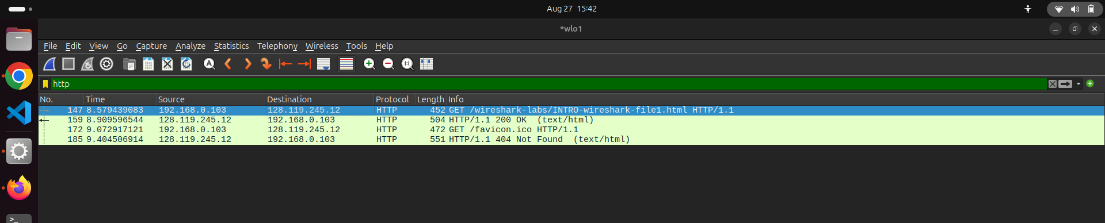
Time= 8.989596544 - 8.579439083 = 0.410157461

3. What is the Internet address of the gaia.cs.umass.edu (also known as
www-net.cs.umass.edu)? What is the Internet address of your computer
or (if you are using the trace file) the computer that sent the HTTP GET
message?
To answer the following two questions, you’ll need to select the TCP packet containing
the HTTP GET request. The purpose of these next two questions is to familiarize you
with using Wireshark’s “Details of selected packet window”; see Figure 3. To answer
the first question below, then look in the “Details of selected packet” window toggle the
triangle for HTTP (your screen should then look similar to Figure 5); for the second
question below, you’ll need to expand the information on the Transmission Control
Protocol (TCP) part of this packet.
Ans -
While Sending GET-
Source Address : 192.168.0.103 (My Computer)
Target Address : 128.119.245.12 (Server Address)
While receiving OK -
Source Address : 128.119.245.12 (My Computer)
Target Address : 192.168.0.103 (My Computer)

4. Expand the information on the HTTP message in the Wireshark “Details of
selected packet” window (see Figure 3 above) so you can see the fields in the
HTTP GET request message. What type of Web browser issued the HTTP
request? The answer is shown at the right end of the information following the
“User-Agent:” field in the expanded HTTP message display. [This field value in
the HTTP message is how a web server learns what type of browser you are
using.]
● Firefox, Safari, Microsoft Internet Edge, Other

Ans-
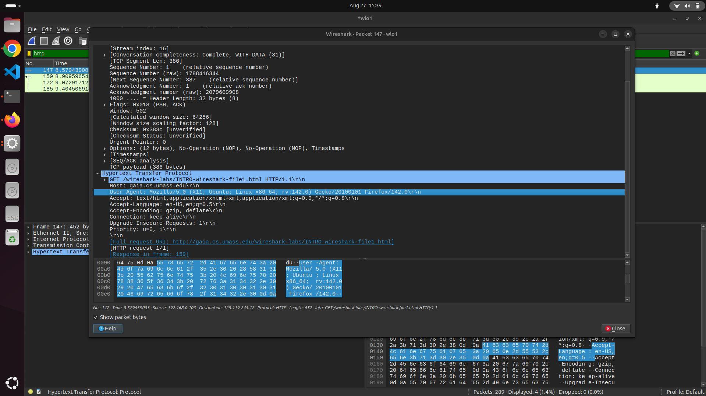
What type of Web browser issued the HTTP Request?
Mozilla Firefox
Mozilla/5.0 (X11; Ubuntu; Linux x86_64; rv:142.0)

5. Expand the information on the Transmission Control Protocol for this packet in
the Wireshark “Details of selected packet” window (see Figure 3 in the lab
writeup) so you can see the fields in the TCP segment carrying the HTTP
message. What is the destination port number (the number following “Dest Port:”
for the TCP segment containing the HTTP request) to which this HTTP request is
being sent?

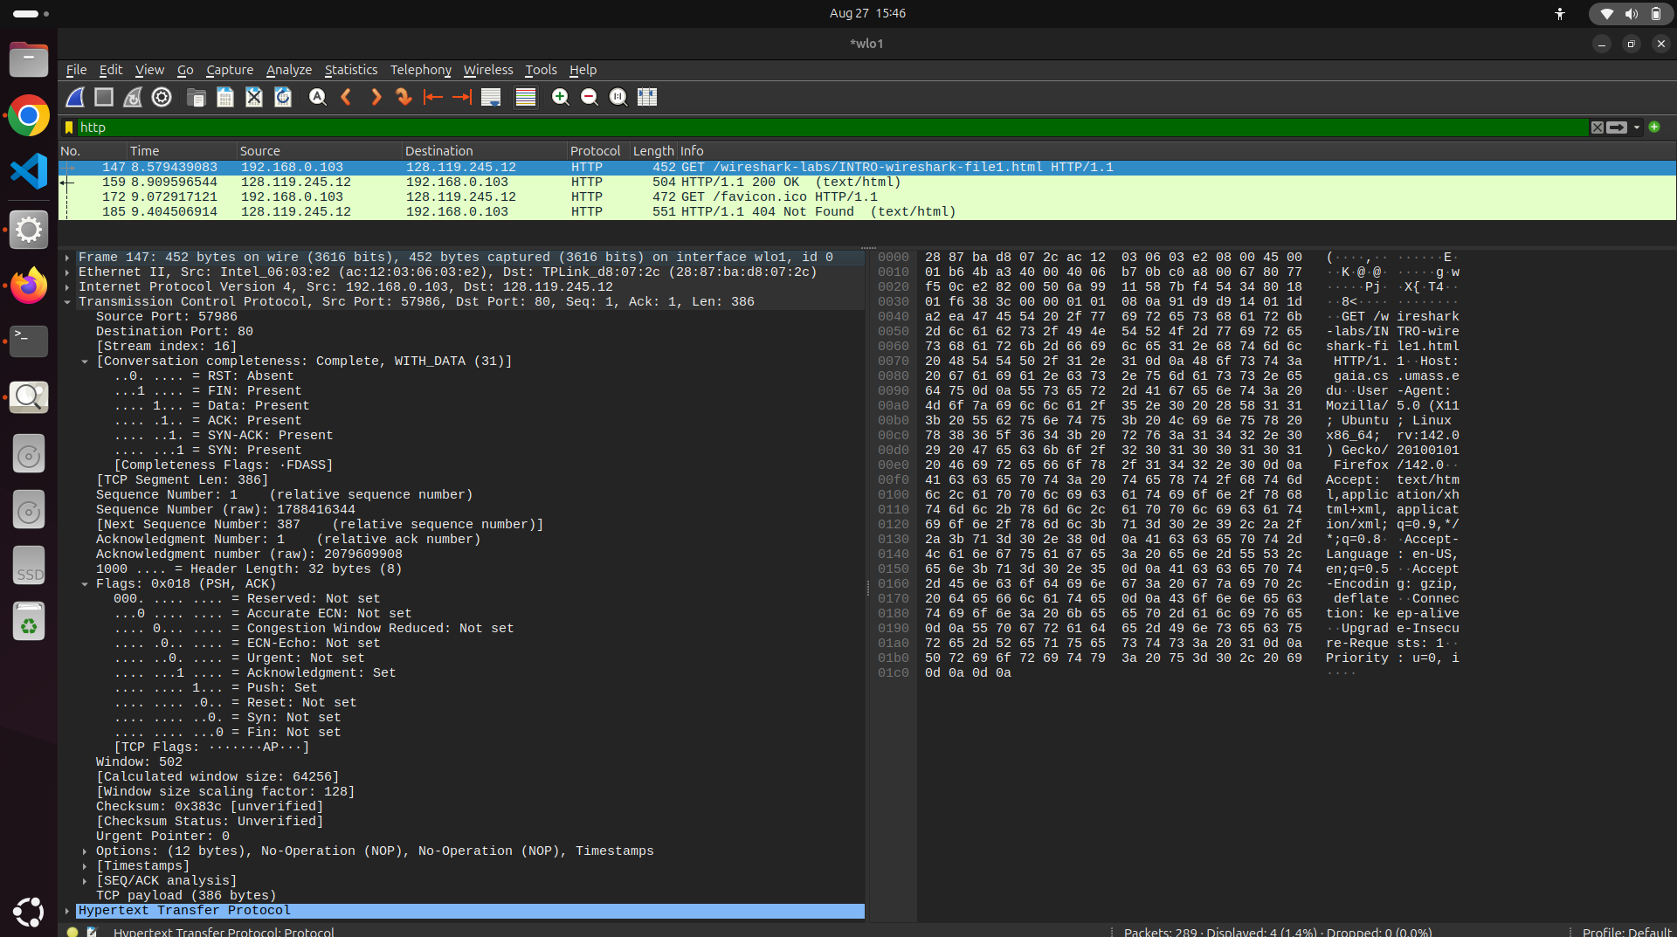
Source Port : 57986
Destination Port : 80

6. Print the two HTTP messages (GET and OK) referred to in question 2
above. To do so, select Print from the Wireshark File command menu, and
select the “Selected Packet Only” and “Print as displayed” radial buttons,
and then click OK.
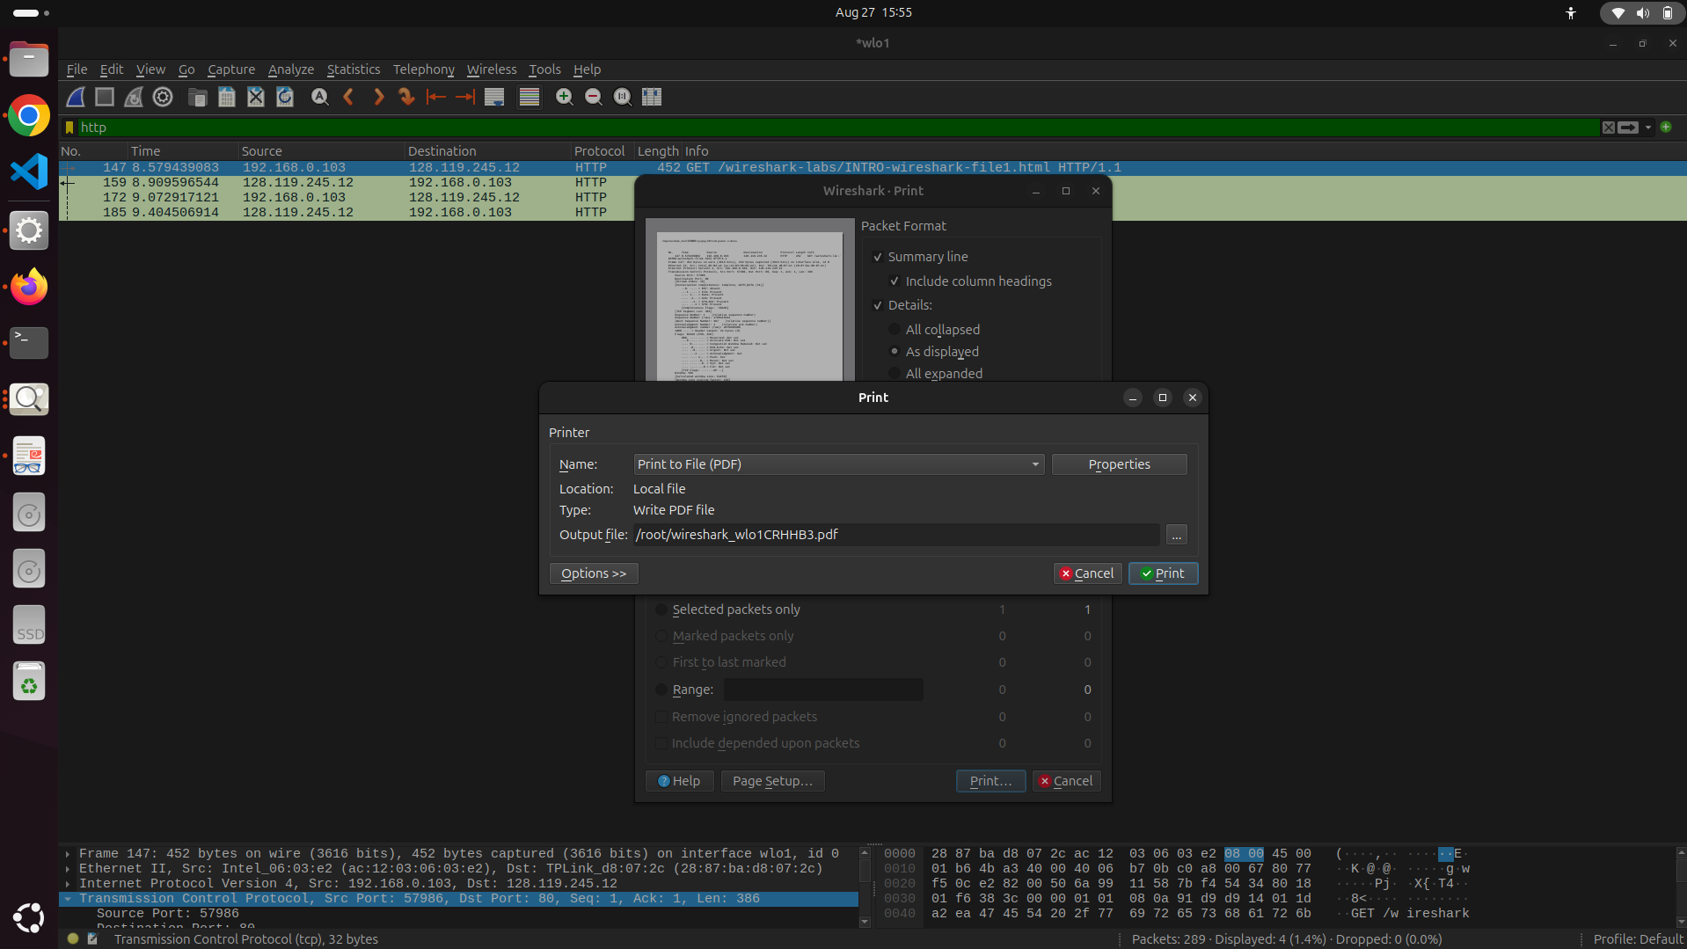
GET -
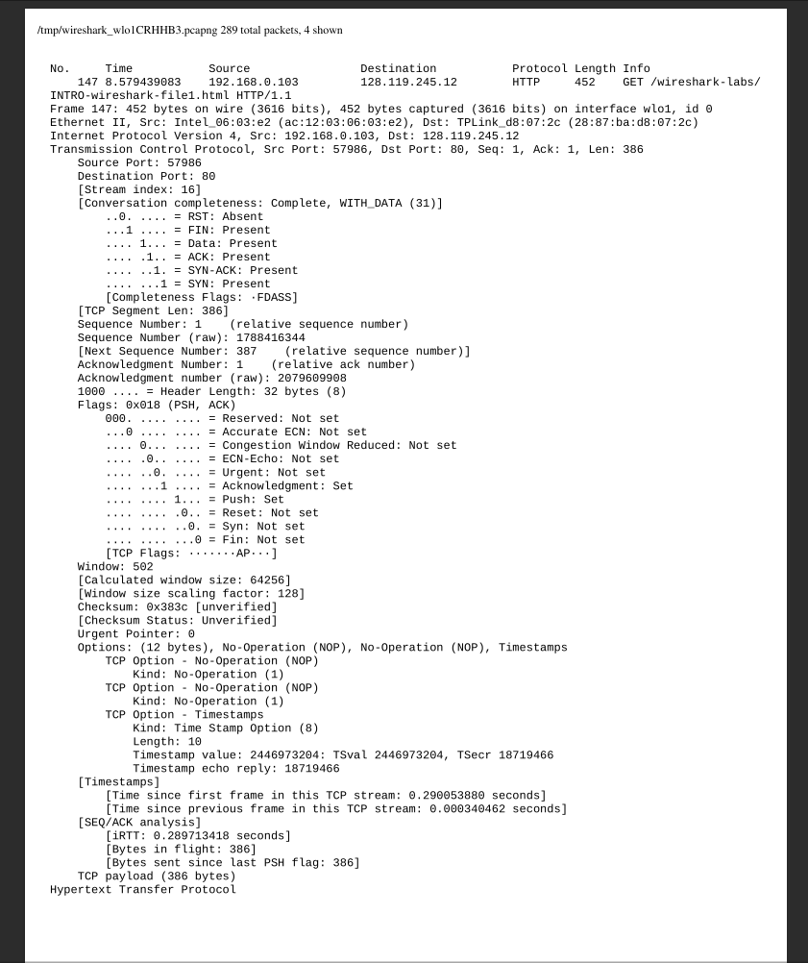

OK -
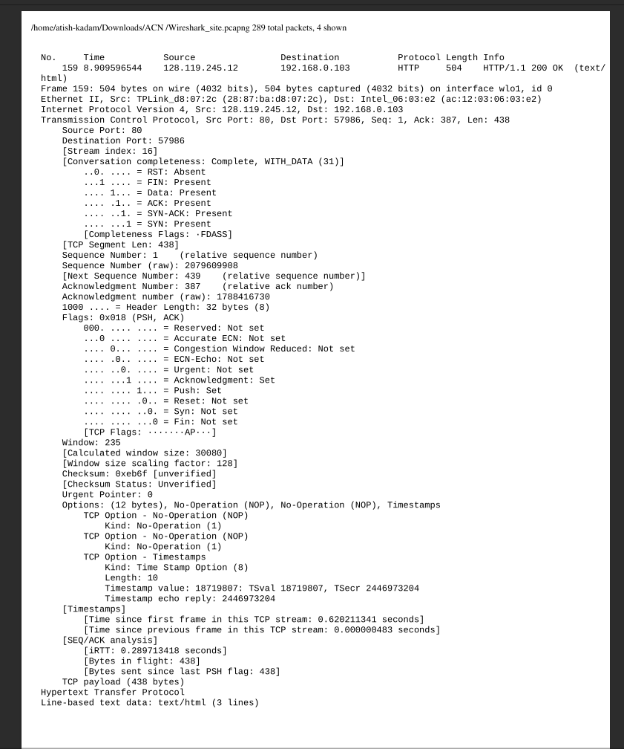

7. Answer Q1-Q3 again by visiting the following links from your web browser.
Save each visit as a separate pcap file.
o https://www.icann.org/

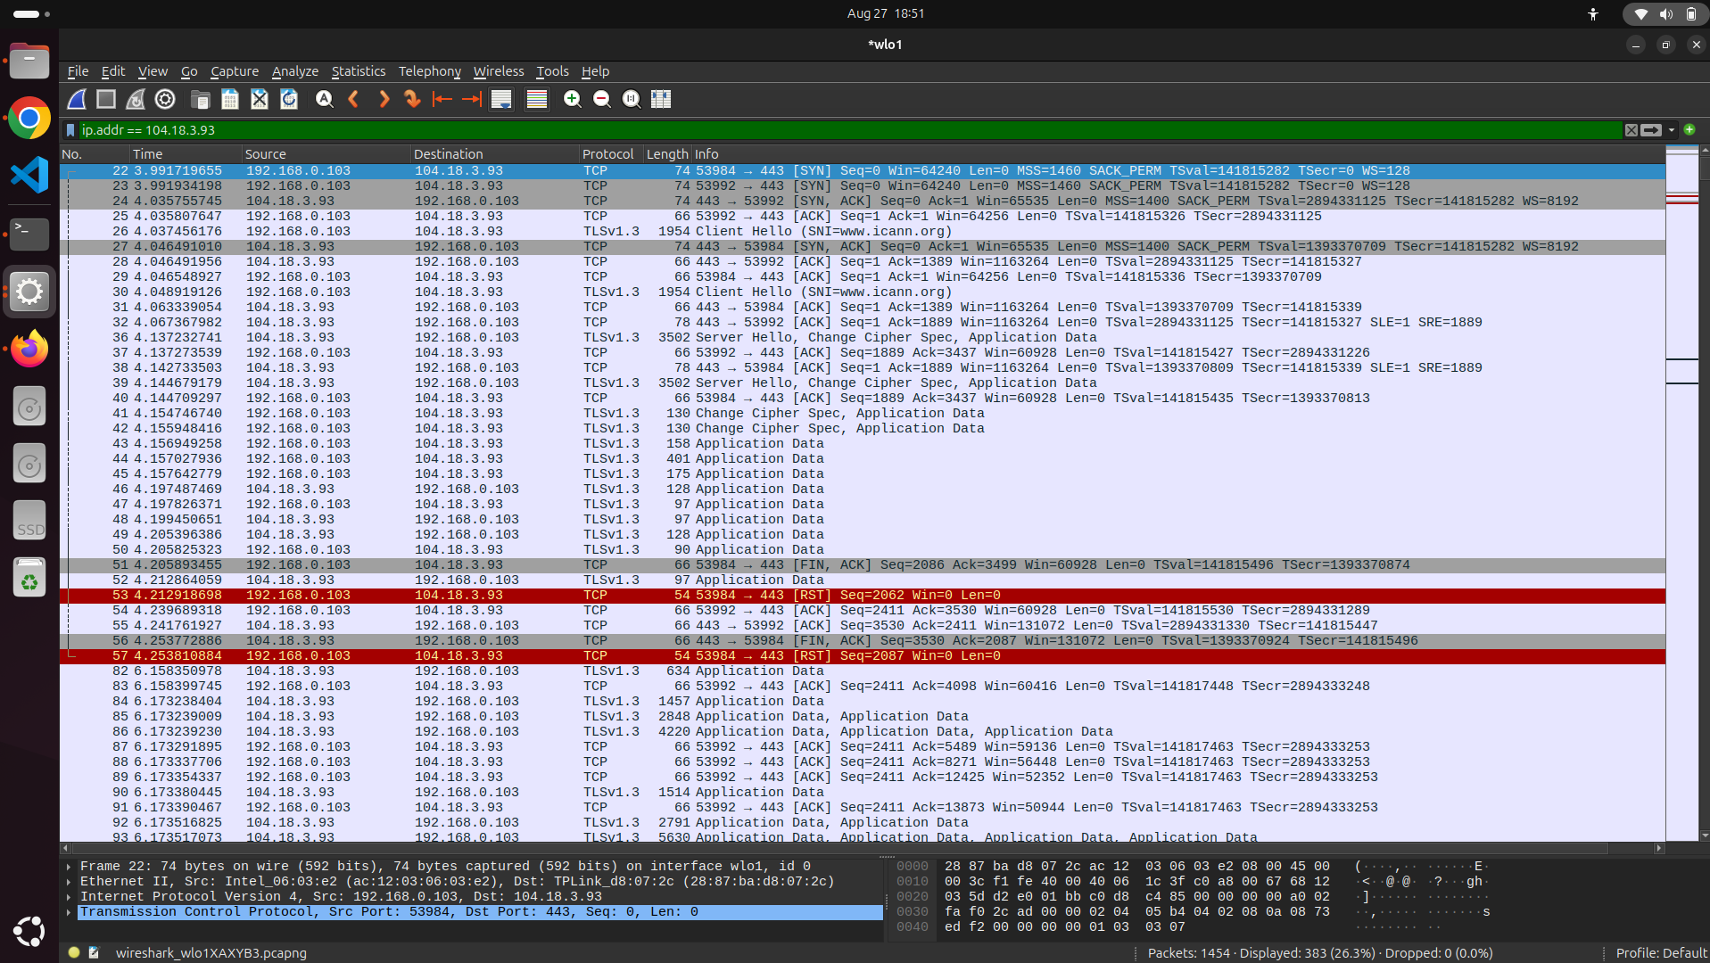

Protocols used - TLSv1.2,TLSv1.3,TCP
(eth,tls,frame,tcp,ip) – copied from statistics->protocol hierarchy
Time -
- We dont get any HTTP messages (GET and OK)
- The Browser (Mozilla Firefox) first sends a TLS handshake to the ICANN server to establish a secure connection.
- Once the connection is established
- We dont see the HTTP message on wireshark as it is hidden in TLS messages

Calculating Time between Client hello and Server hello
4.137232741 (Server Hello)- 4.048919126 (Client Hello)= 0.088313615 seconds
Time taken by the server to respond to clients initial secure connection request.

While Client hello ->
Source IP (My PC): 192.168.0.103
Destination IP (ICANN server): 104.18.3.93
While Server hello ->
Source IP (ICANN server): 104.18.3.93
Destination IP (My PC): 192.168.0.103

o http://example.com
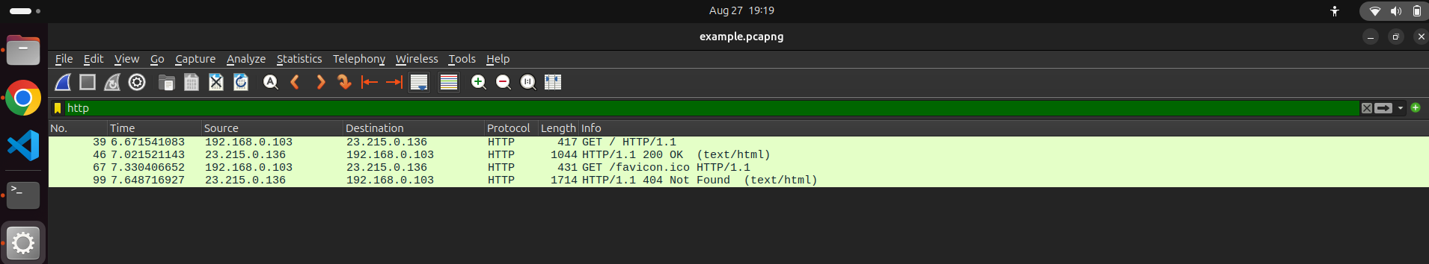
Protocols used - (Ipv6,eth,icmpv6,udp,tls,igmp,data,frame,arp,http,data-text-lines,quic,tcp,dns,ip) – copied from statistics->protocol hierarchy
Time - 7.021521143 - 6.671541083 = ~0.34998 seconds

While Client hello ->
Source IP (My PC): 192.168.0.103
Destination IP (ICANN server): 23.215.0.136
While Server hello ->
Source IP (ICANN server): 23.215.0.136
Destination IP (My PC): 192.168.0.103

o www.youtube.com
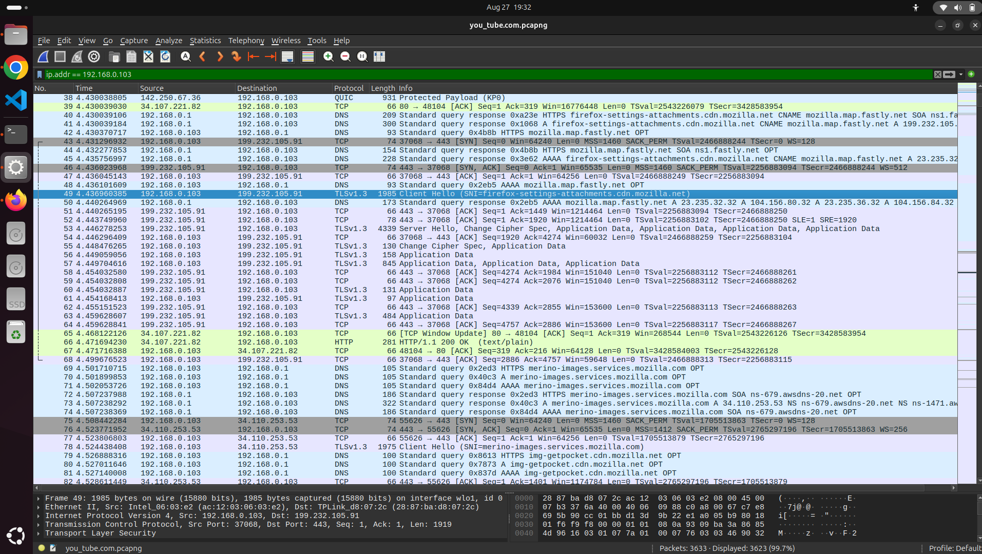

Protocols used - (Ipv6,eth,udp,tls,data,mdns,frame,arp,http,data-text-lines,quic,tcp,dns,icmp,ip) – copied from statistics->protocol hierarchy
Time -
- We dont get any HTTP messages (GET and OK)
- The Browser (Mozilla Firefox) first sends a TLS handshake to the ICANN server to establish a secure connection.
- Once the connection is established
- We dont see the HTTP message on wireshark as it is hidden in TLS messages

Calculating Time between Client hello and Server hello
4.446278253 - 4.436960385= 0.009317868 seconds
Time taken by the server to respond to clients initial secure connection request.

While Client hello ->
Source IP (My PC): 192.168.0.103
Destination IP (You tube server): 199.232.105.91

While Server hello ->
Source IP (You tube server): 199.232.105.91
Destination IP (My PC): 192.168.0.103

8. Compare and contrast what you observed in Wireshark or in your browser
when you visited the above four websites. Does your output vary when
revisiting the same site after some time? Why or why not?

9. Wireshark also helps to gather a lot of stats about the flows. Refer to this
help page for more details:
https://www.wireshark.org/docs/wsug_html_chunked/ChStatistics.html
Your task is to take one of the pcaps that you collected when you visited
different websites and present some interesting stats like packet lengths,
Flow Graphs, TCP Throughput, etc. You can insert screenshots into your
assignment report and briefly comment on key takeaways.
General statistics
Ans -
Capture File Properties about the capture file.
Protocol Hierarchy of the captured packets.
Conversations e.g., traffic between specific IP addresses.
Endpoints e.g., traffic to and from IP addresses.
I/O Graphs visualizing the number of packets (or similar) in time.

The “Capture File Properties” Dialog
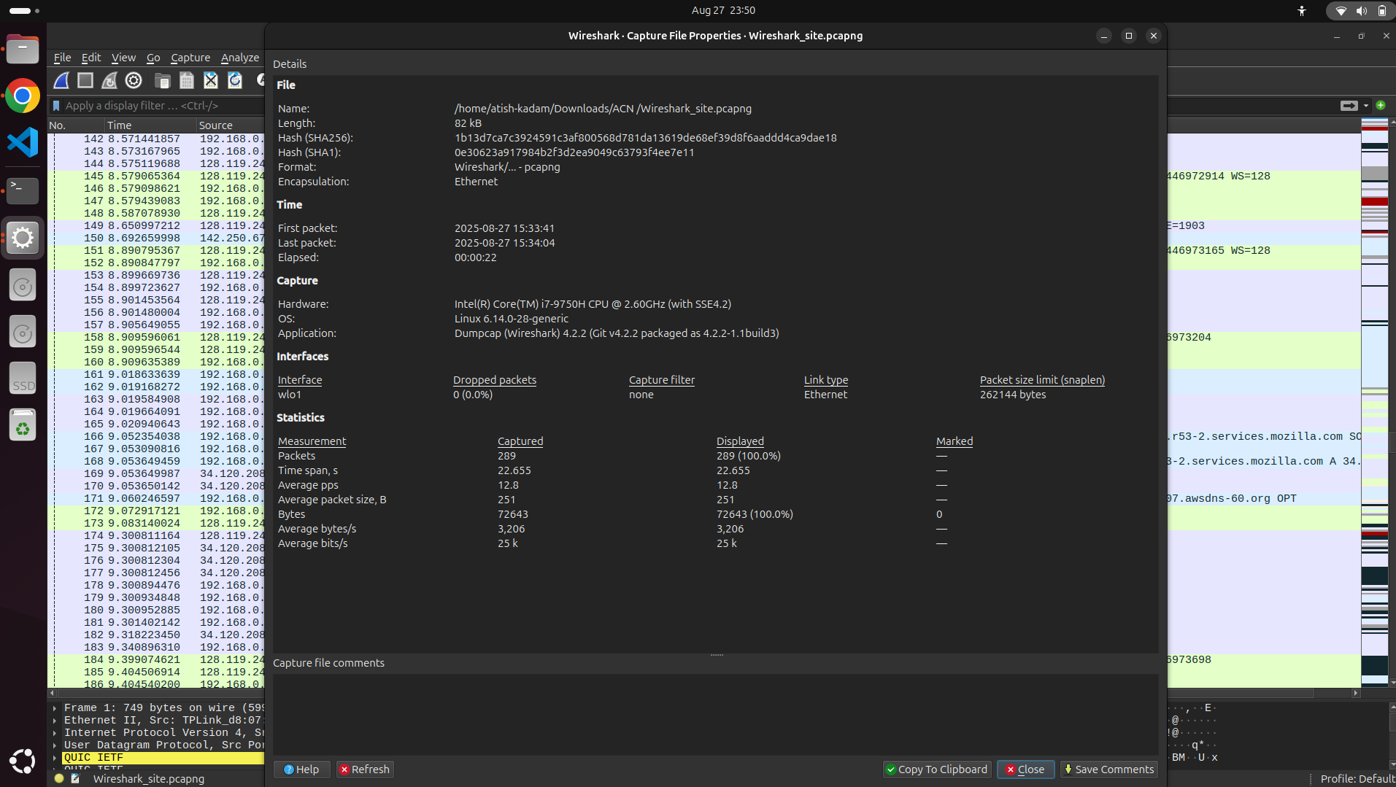

The “Protocol Hierarchy” Window

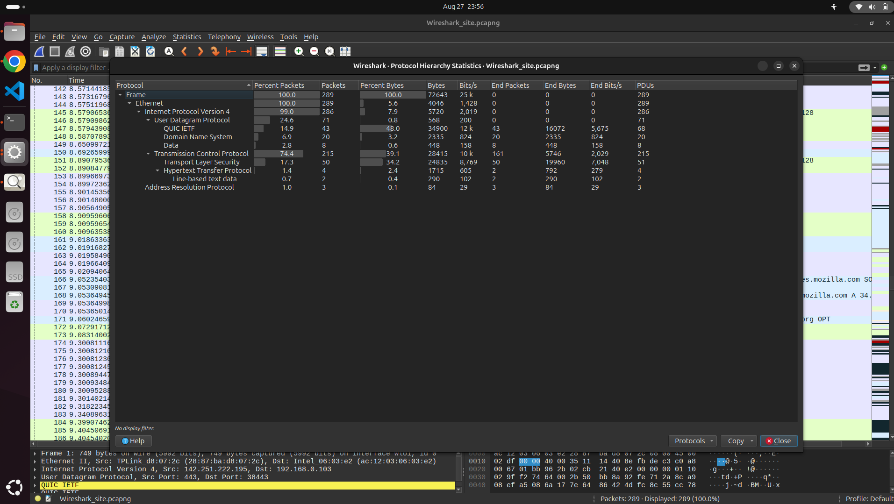

The “Conversations” Window
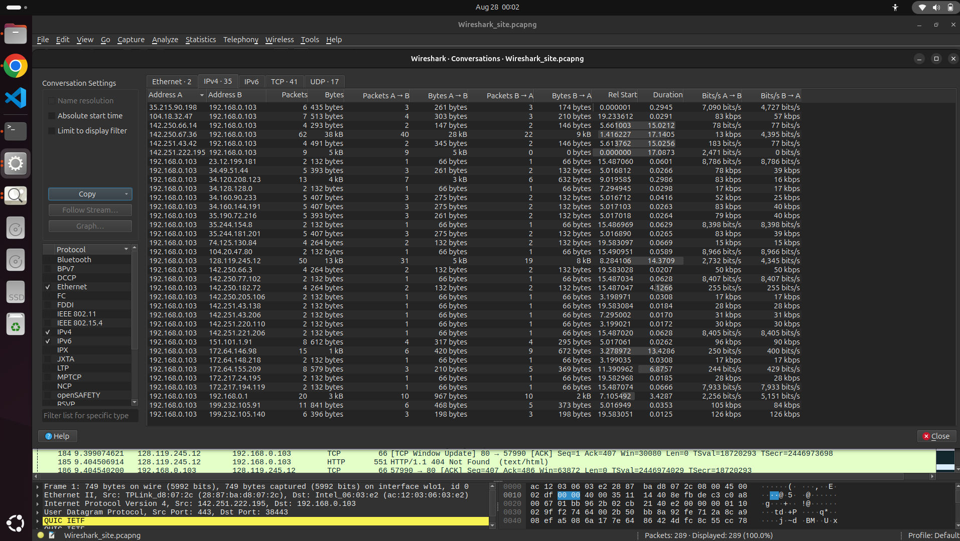

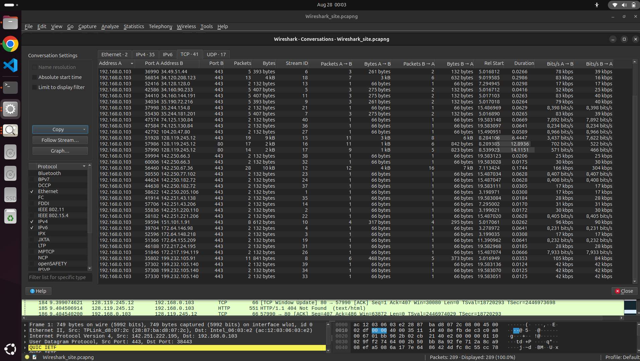
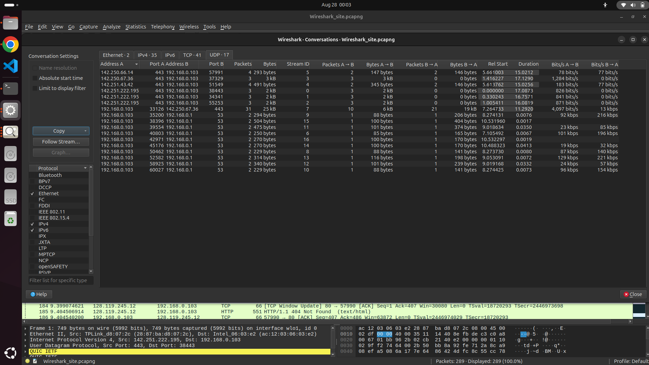

The “Endpoints” Window
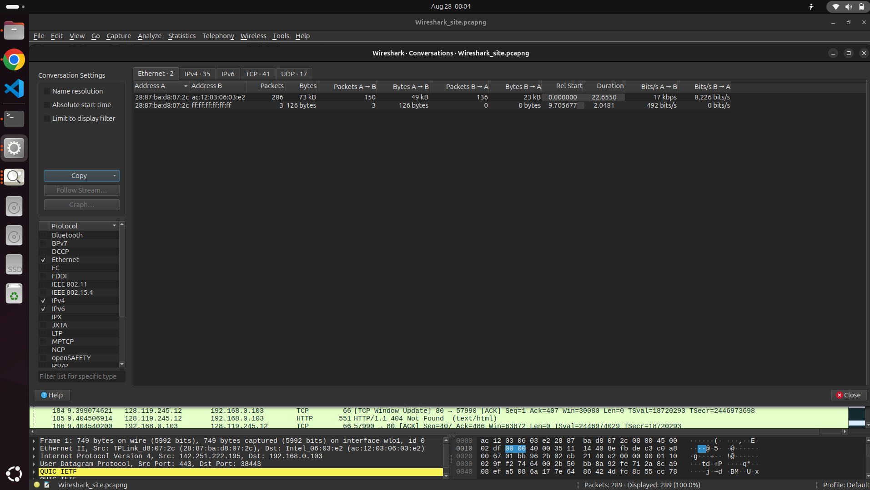

Packet Lengths
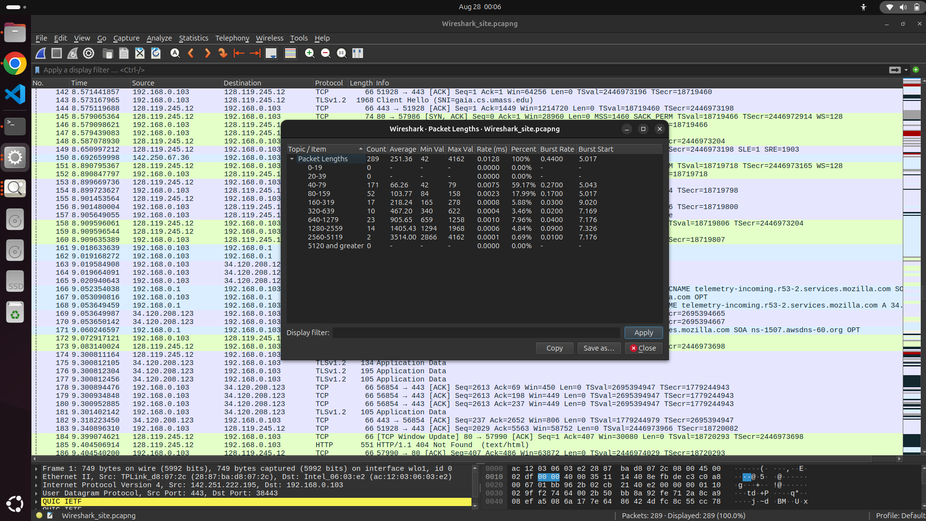

The “I/O Graphs” Window
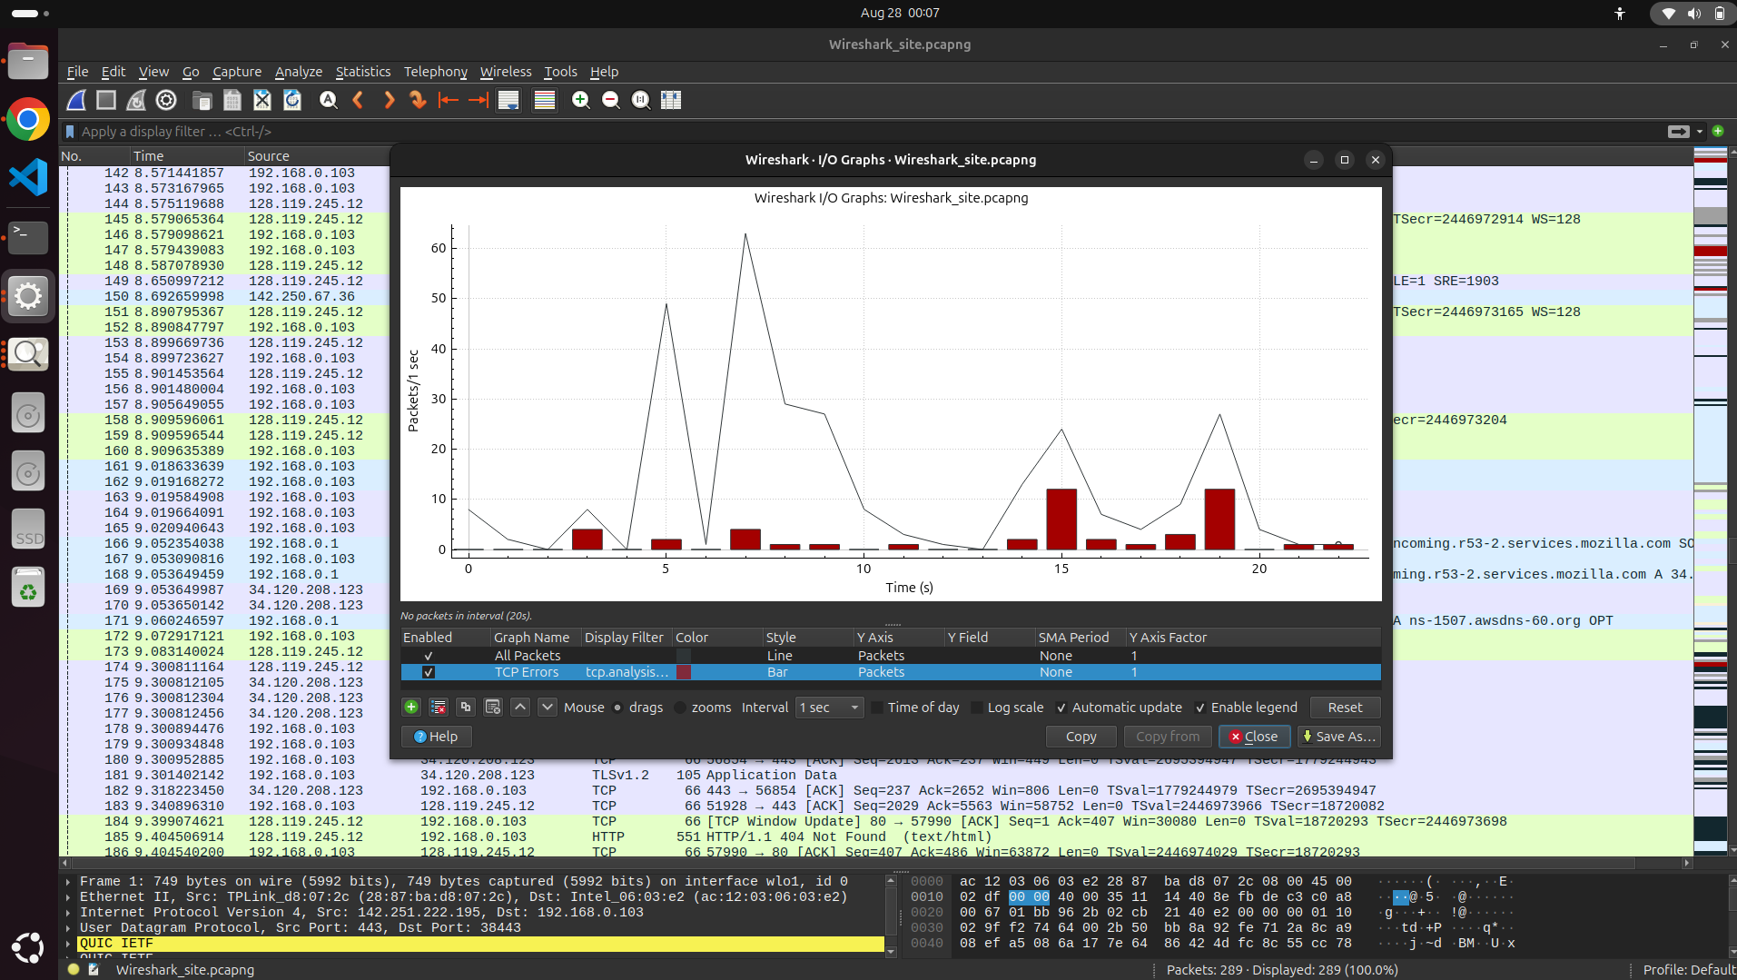

PART-B: Analyze packet trace of traceroute session

Task-1: Capture traceroute traffic to/from one of the websites visited as part of
PART-A using wireshark and answer the following in a google doc. Feel free to
include screenshots from terminal/wireshark to support your answers. [8 Marks]
1. What protocol among ICMP/TCP/UDP is used to send probe packets?
Identity key fields and comment on their values.
Ans -
UDP - It is used to send probe packets
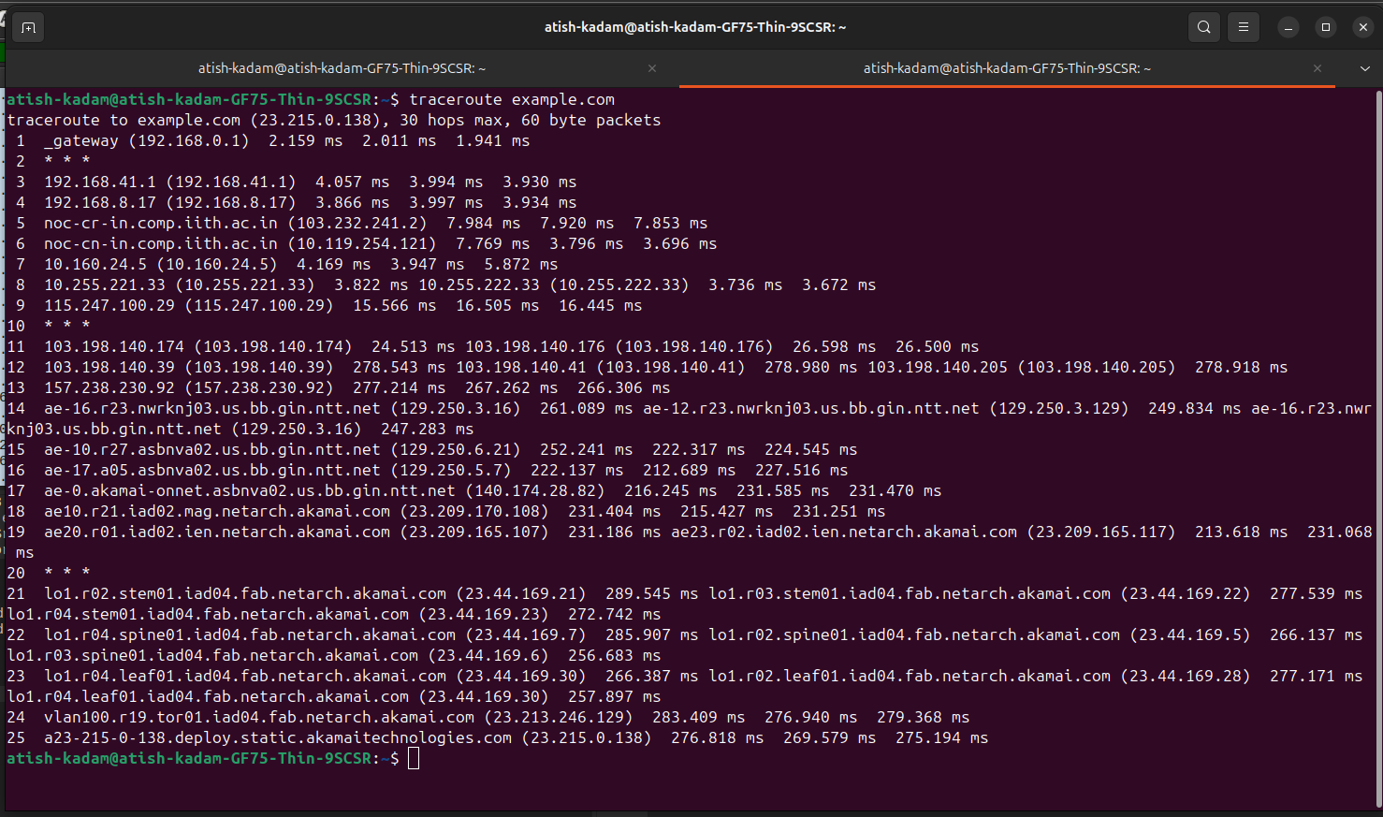

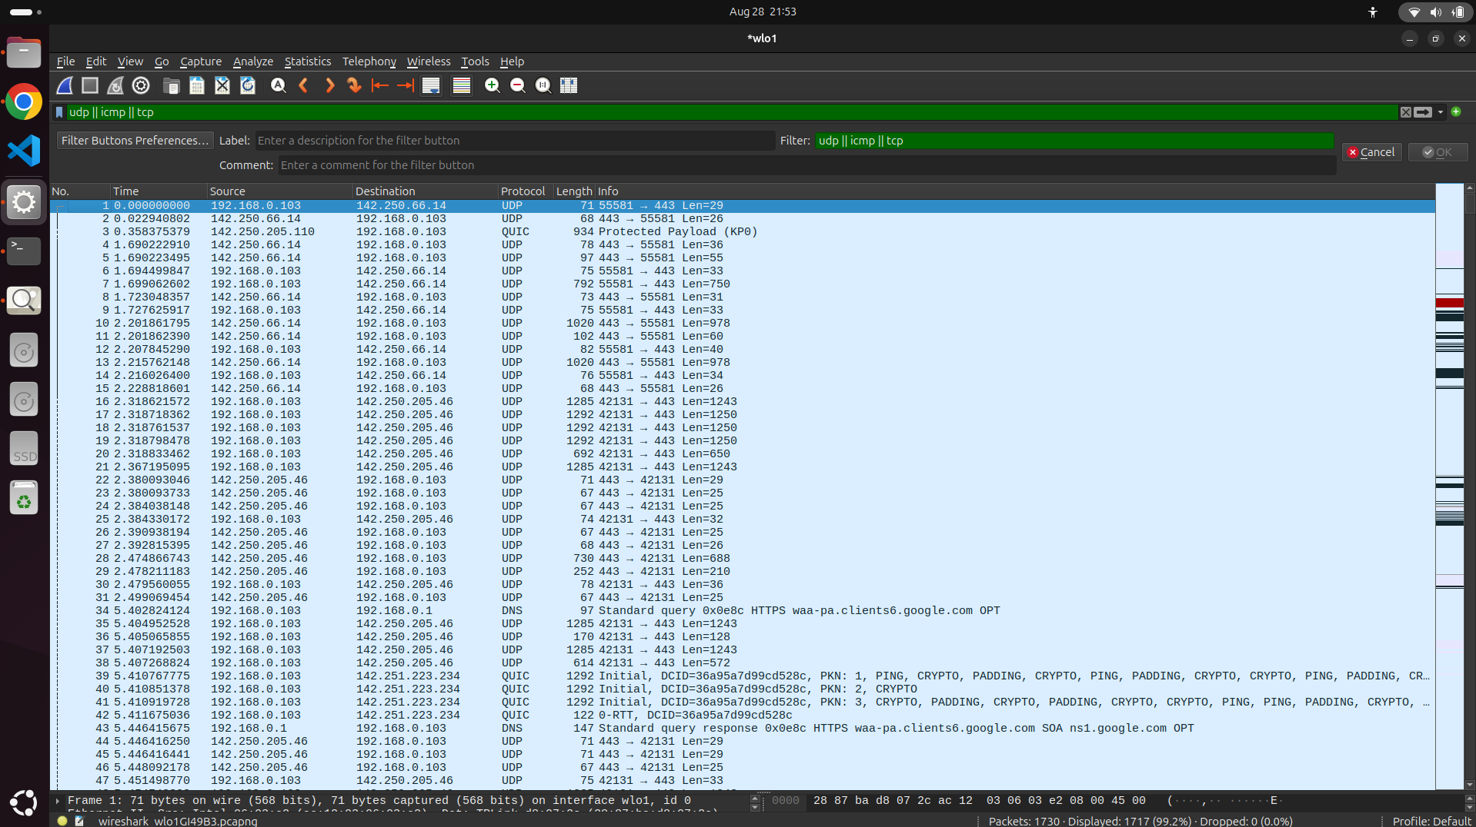

2. Can you change the default protocol used to send probes? Demonstrate it
and comment on how the last probe response differs among
ICMP/TCP/UDP.
Sol -
For UDP packets
When i run traceroute example.com on terminal
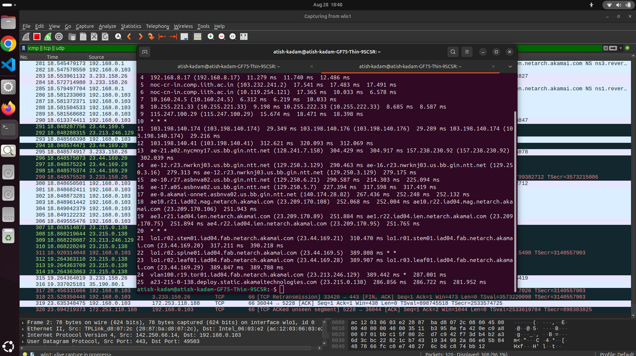

For ICMP-
When i run traceroute -I example.com on terminal
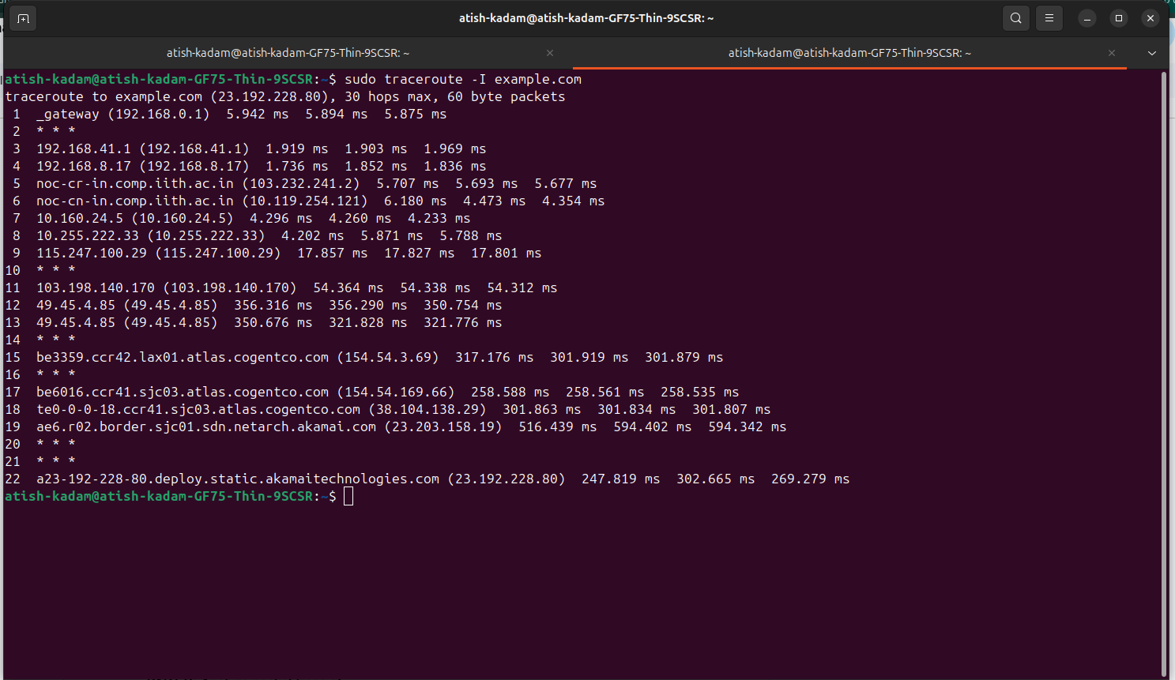

For TCP
When i run traceroute -T example.com on terminal
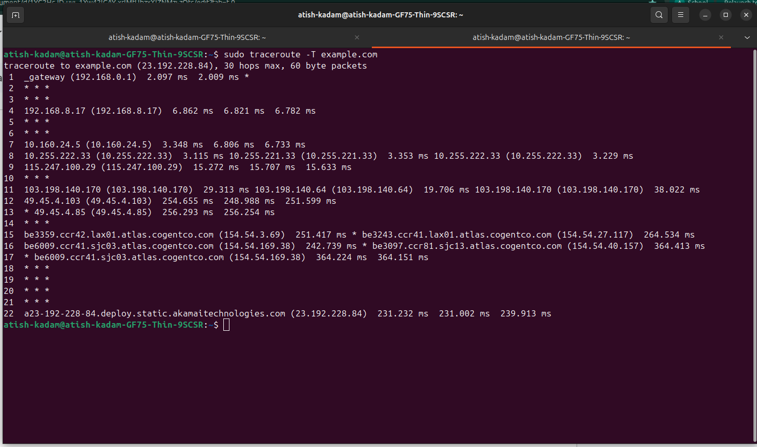

3. What is the typical gap (delay) between probe packets?
Ans -
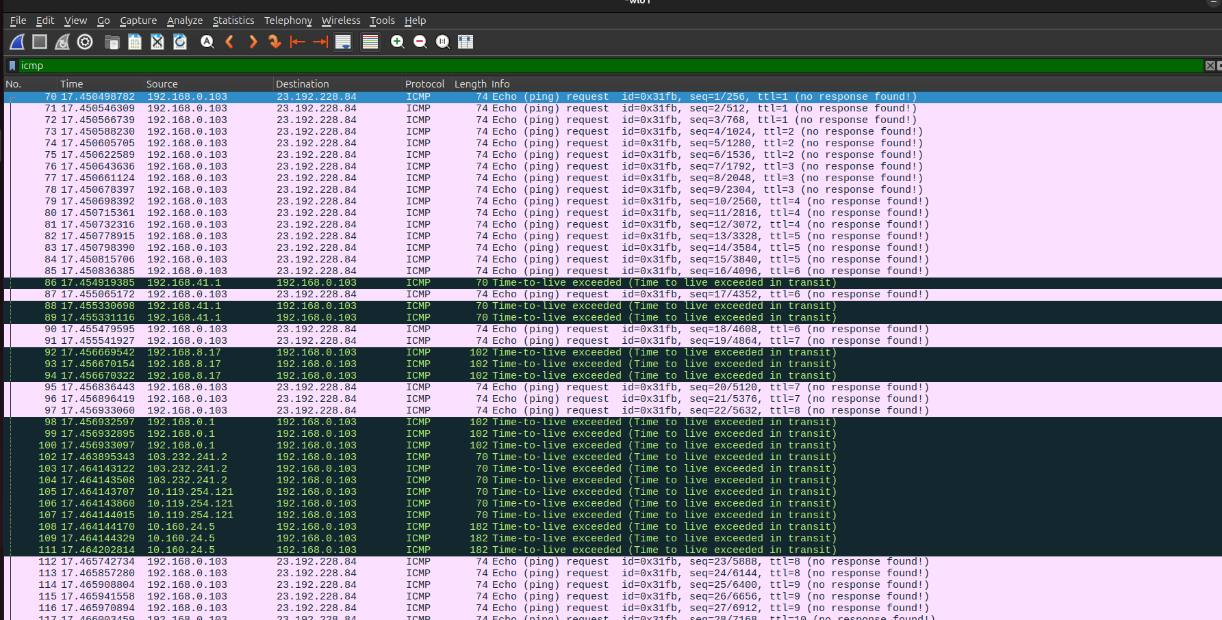
For TTL=1
Packet -70
Packet - 71
Packet - 72
(Packet 71 -Packet 70)=17.450546309-17.450498782=0.000047527
(Packet 72 -Packet 71)=17.450566739-17.450546309=0.000020430

4. What is contained in probe responses? What protocol is used in probe
responses when ICMP/TCP/UDP are used to send probes?
Ans-
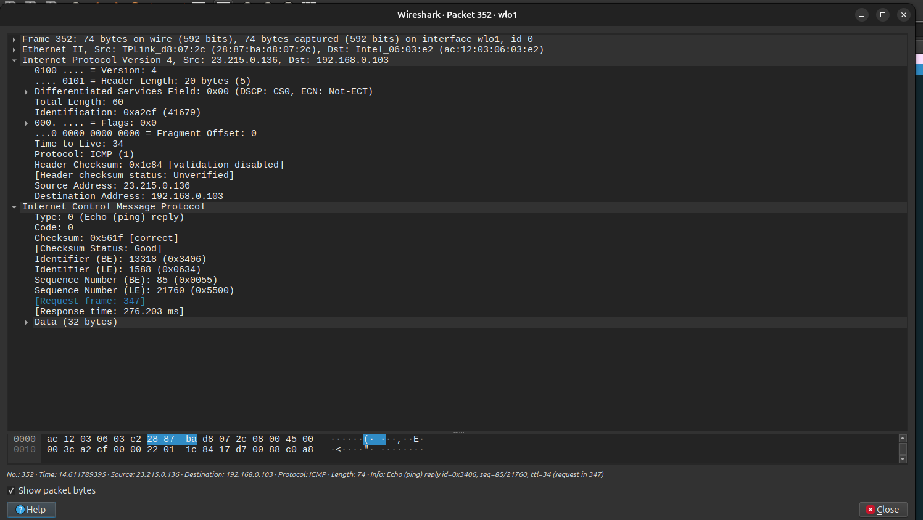

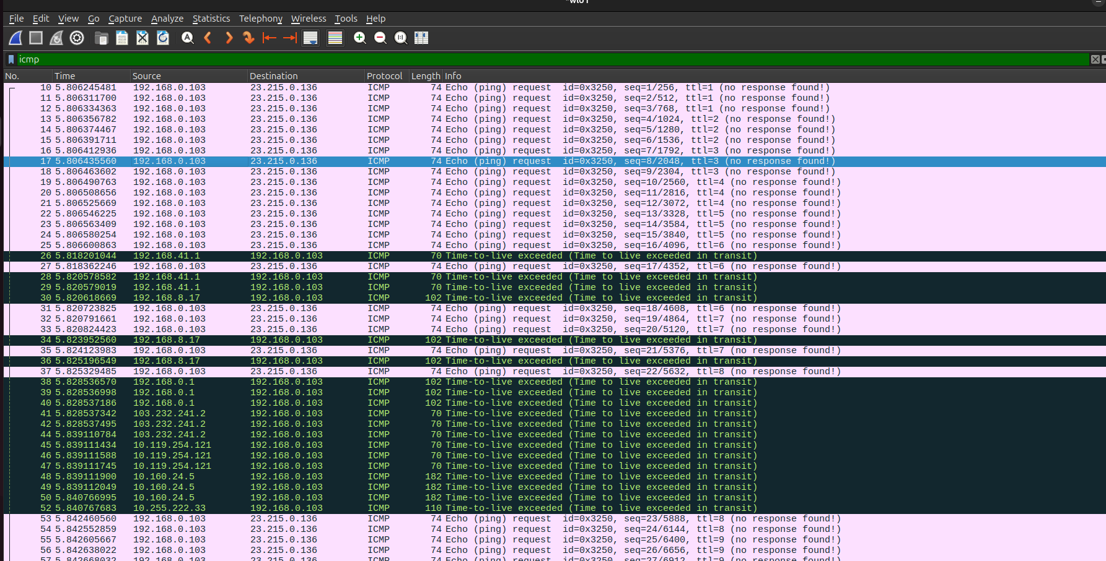
Intermediate Hops - ICMP Time Exceeded
Destination - ICMP Echo Reply

Similarly for TCP -
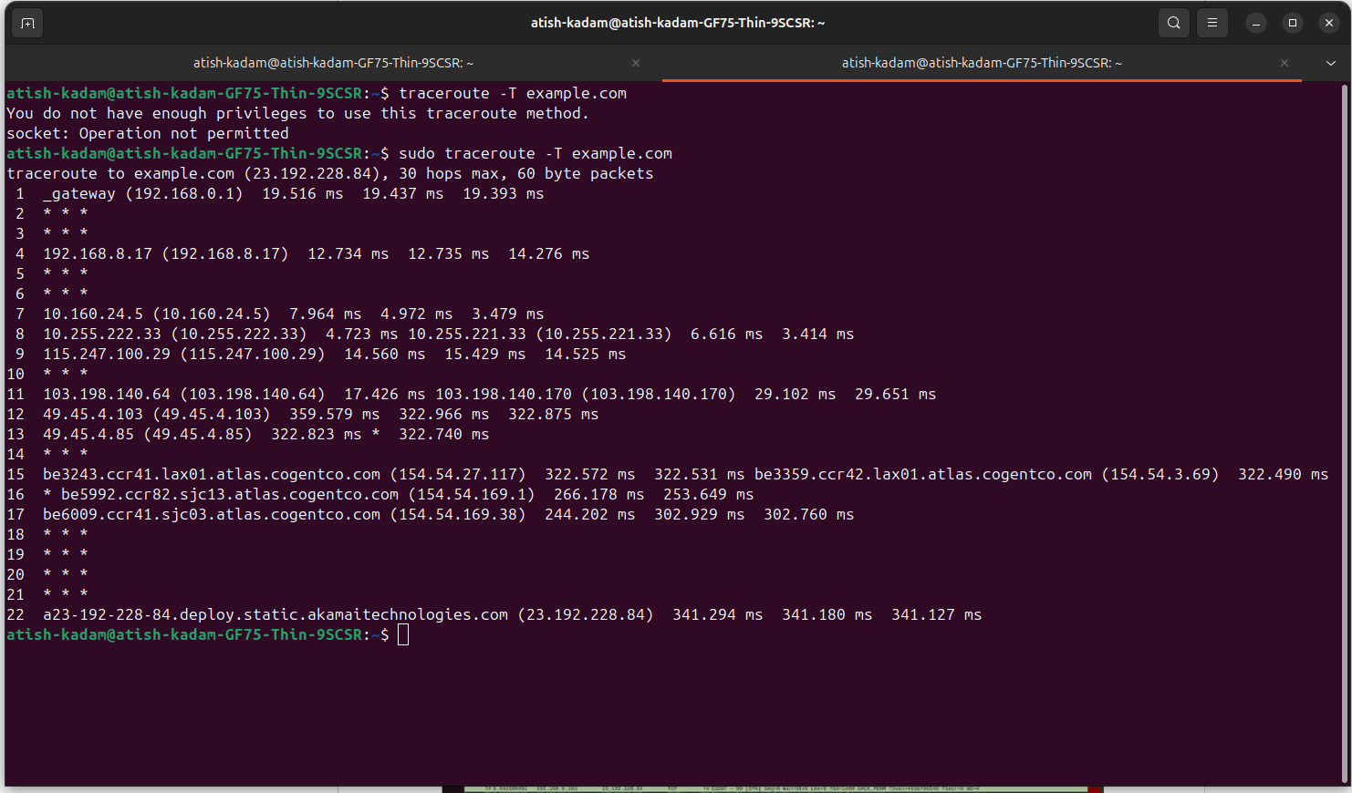
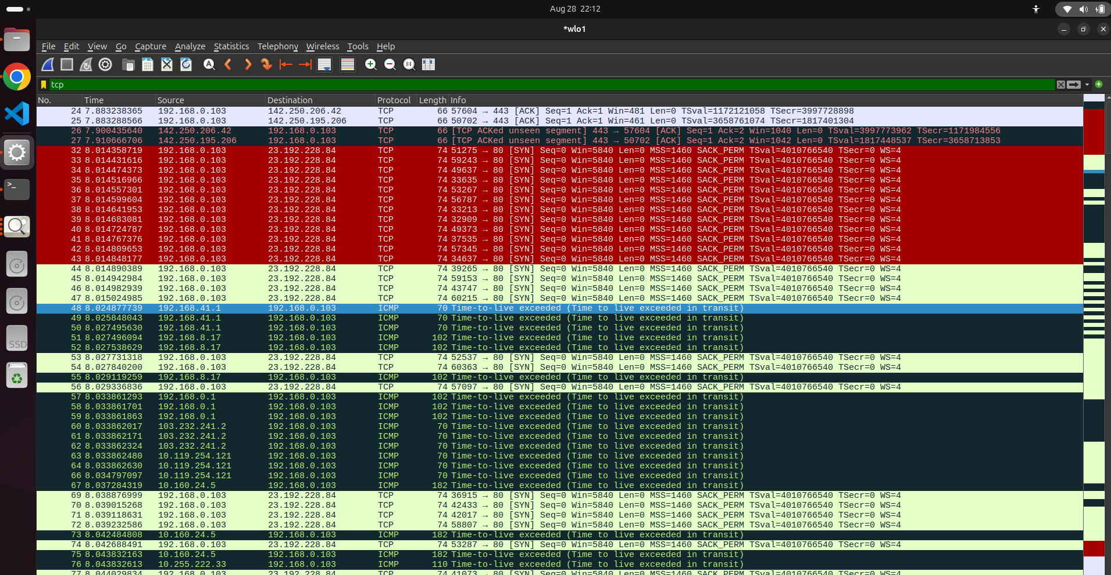
Intermediate hops- ICMP Time Exceeded
Destination - Either TCP SYN/ACK

Similarly for UDP
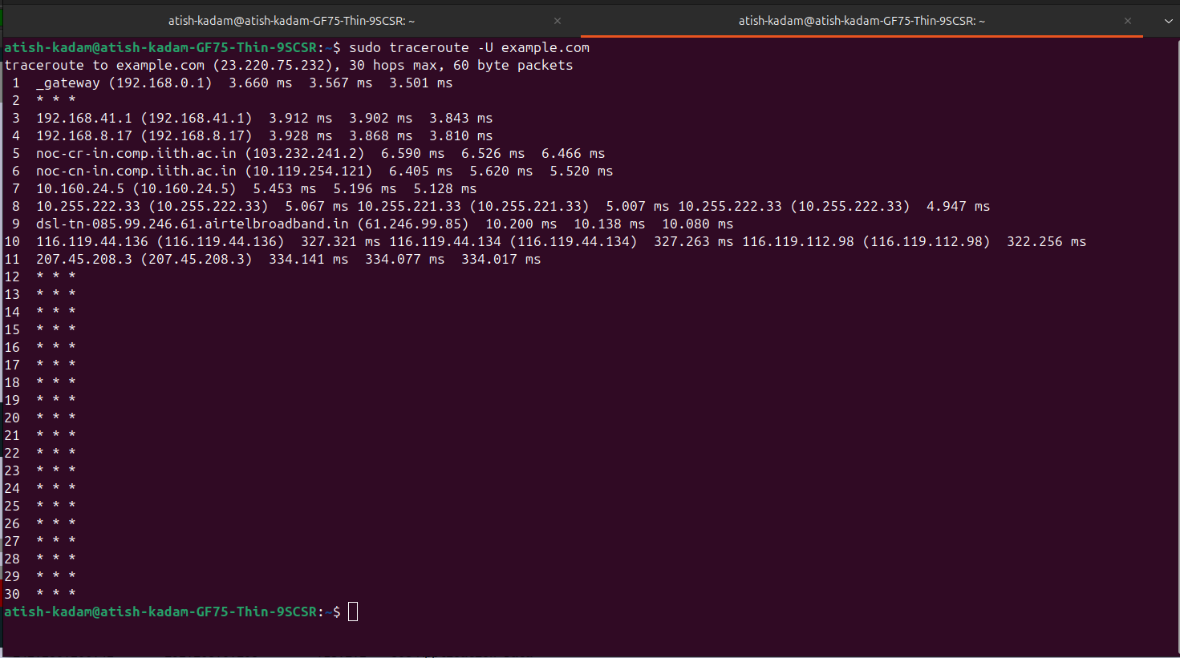
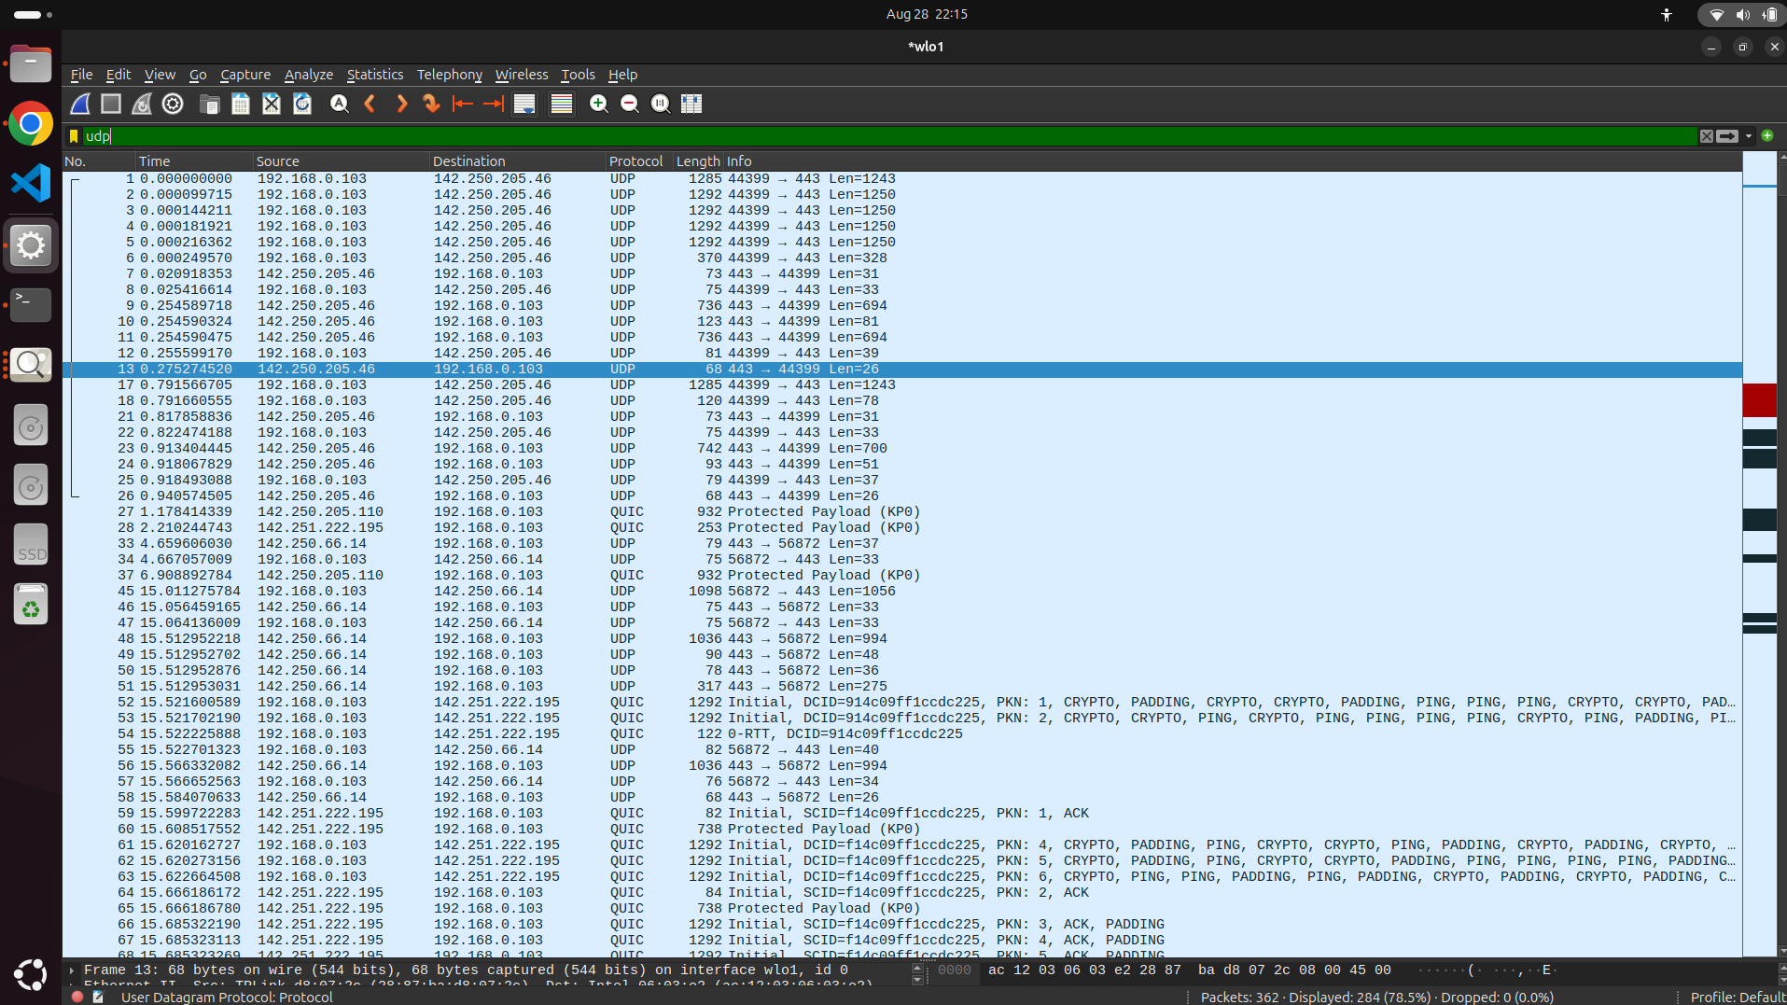
Intermediate Hops - ICMP Time
Destination - UDP (High numbered Ports) and No response

5. Which protocol has TTL field and comment on how the values of this field
varied across probes and responses?
IPV4 Protocol has TTL Field.For each Probe value of TTL increased by One for Each Hop.
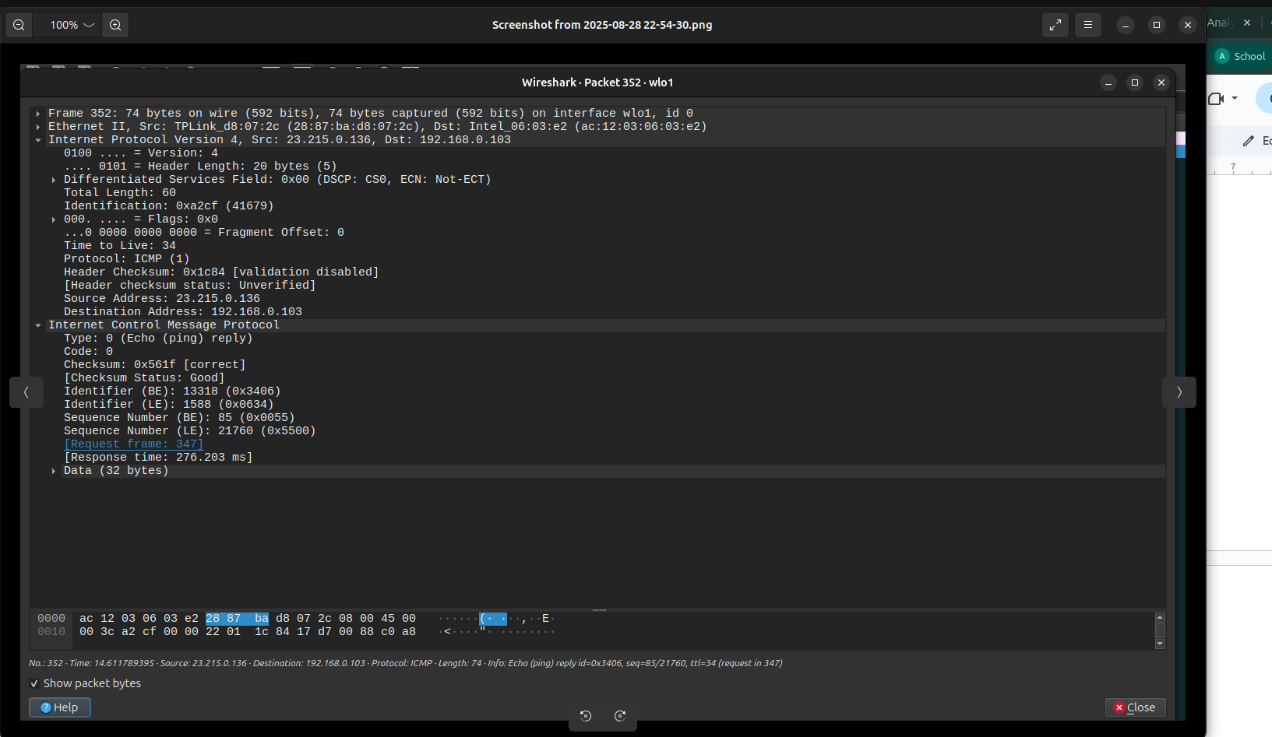
6. How long did it take to get the output of the traceroute session? Which is
the bottleneck router?
ICMP BottleNeck Router
49.45.4.85
Corresponding Jump -
337.50 Seconds
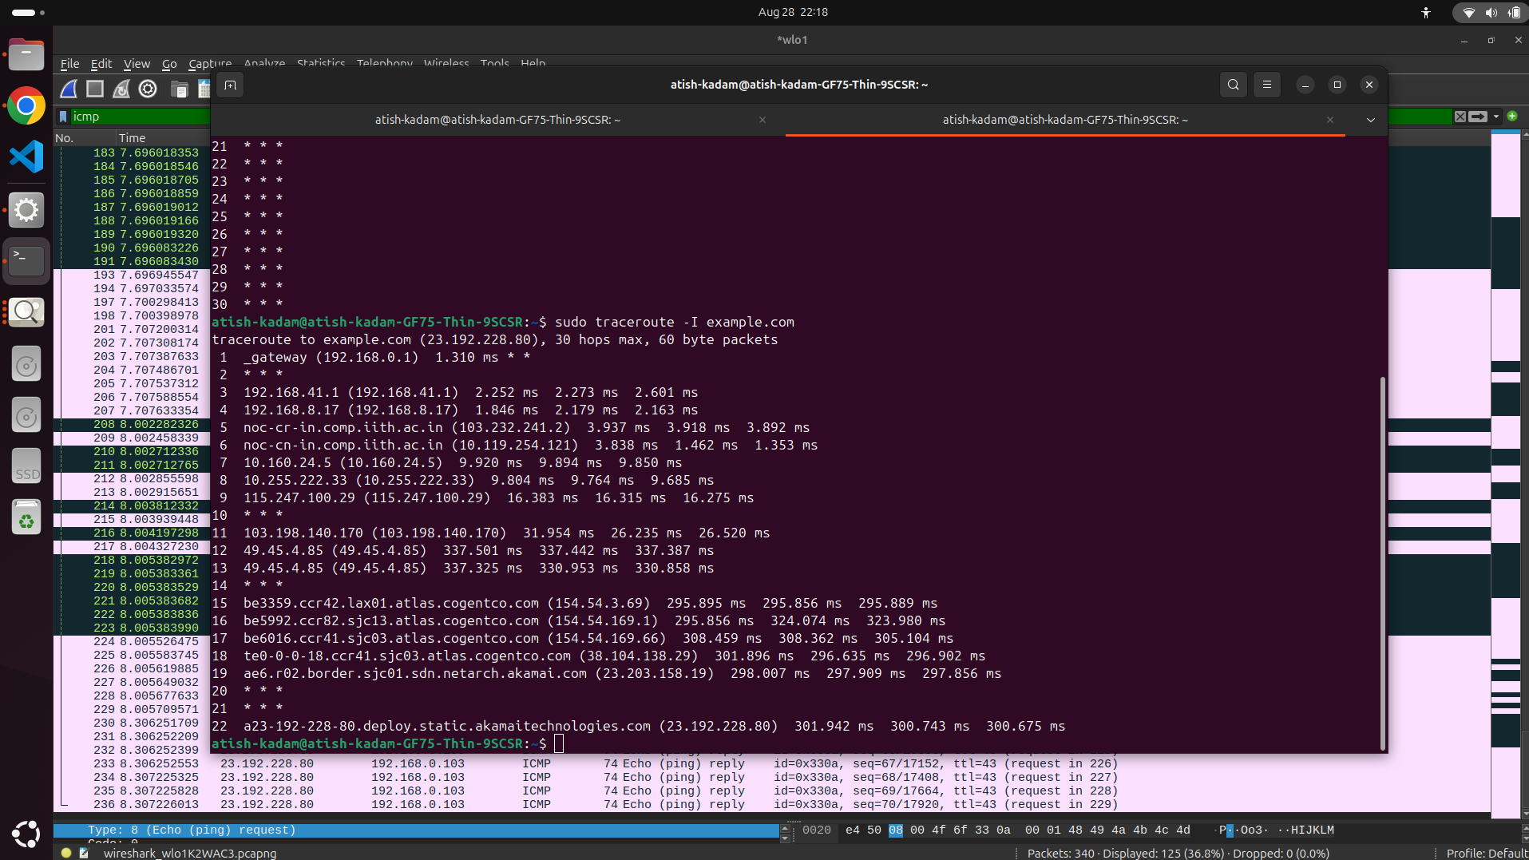
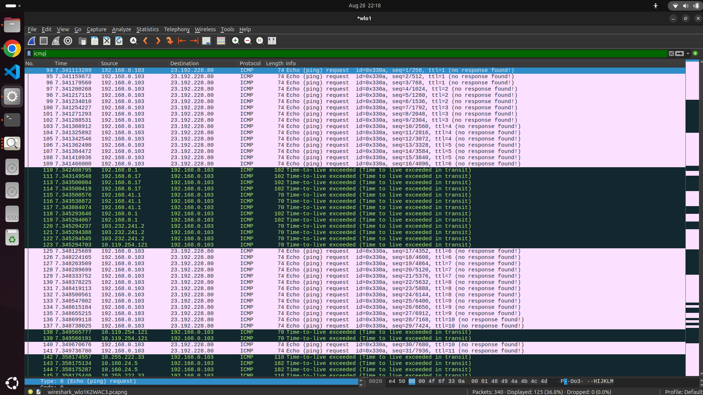

7. Do you see any stars (*) in the output? Discuss the potential reasons
behind the presence of these stars in the output.
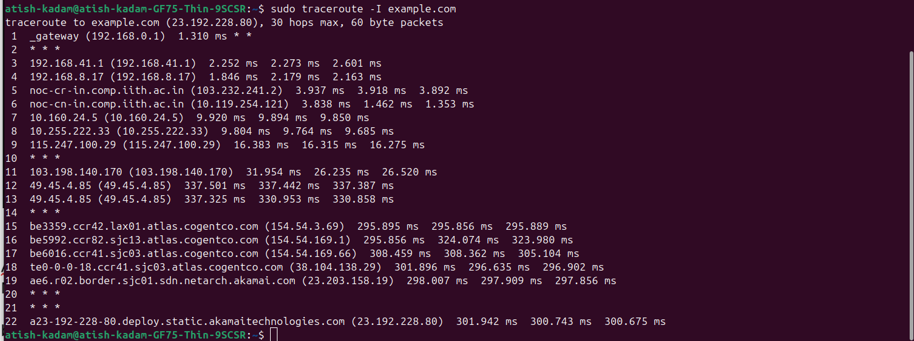
- There are stars (*) in the traceroute data.
- These show up when a router fails to react to at least one of the delivered probes.
- This may occur because the router is too busy, firewalls are blocking ICMP packets, or the router is set up to not respond.
- It's common and doesn't always mean that something is wrong, particularly if the trace goes all the way to the destination.

8. How many probe packets are sent in bursts? What is the inter packet time
difference between consecutive packets in the first burst? How much time
elapsed between the first request and its response?
Ans-
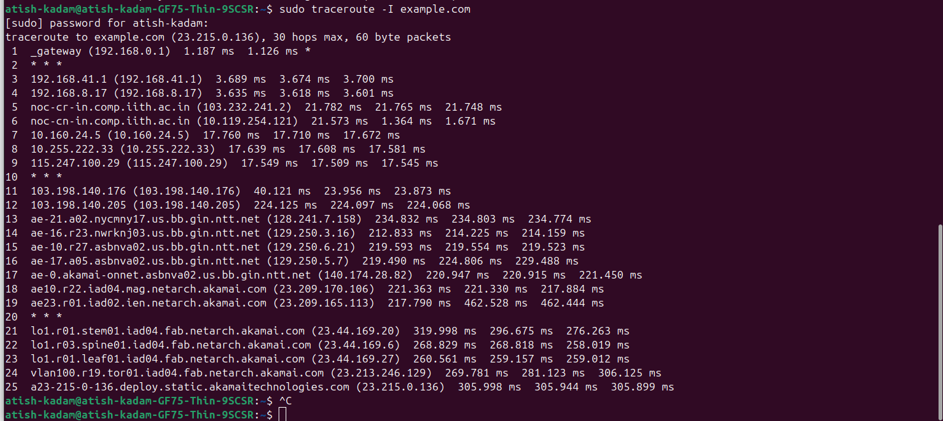
- The terminal output seen above allows us to see that:
- There are three probe packets each burst.
- Based on the difference between the 3 ms and 2 ms readings, the inter-packet time delay between successive packets in the first burst was approximately 1 ms.
- At hop 1, with TTL = 1, the time interval between the initial request and its response was approximately 3 ms.
- Time elapsed between first re quest and its response is 46.263678-45.983575=0.280103 seconds

Task-2: Answer Task-1 Q.6 and Q.8 using tcpdump (yet another packet
capturing tool, no GUI, CLI only) instead of wireshark to capture traffic to/from
one of the remaining websites visited as part of PART-A. Make use of different
filtering options in tcpdump to get concise output for answering these questions.
[2 Marks]

Ans -
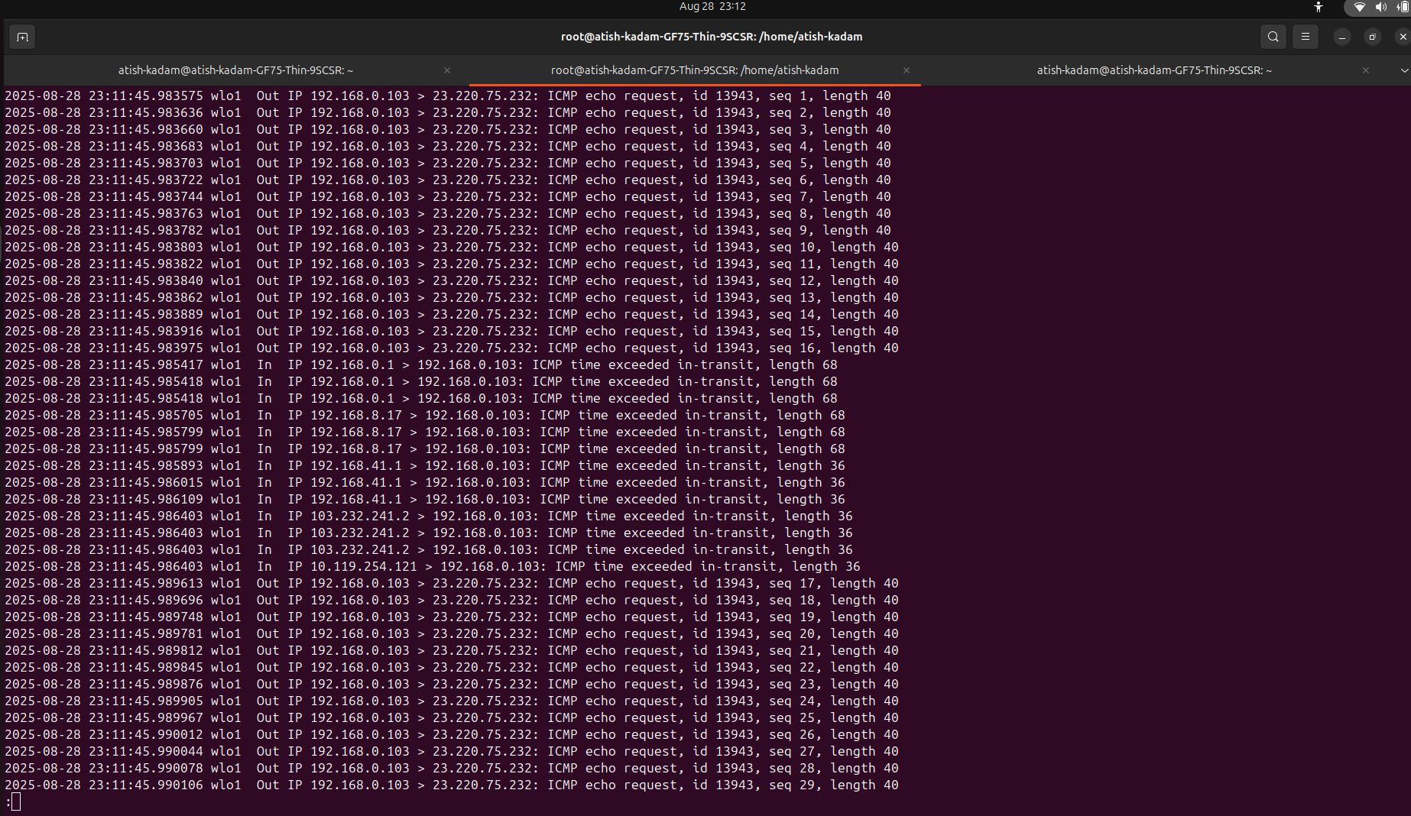
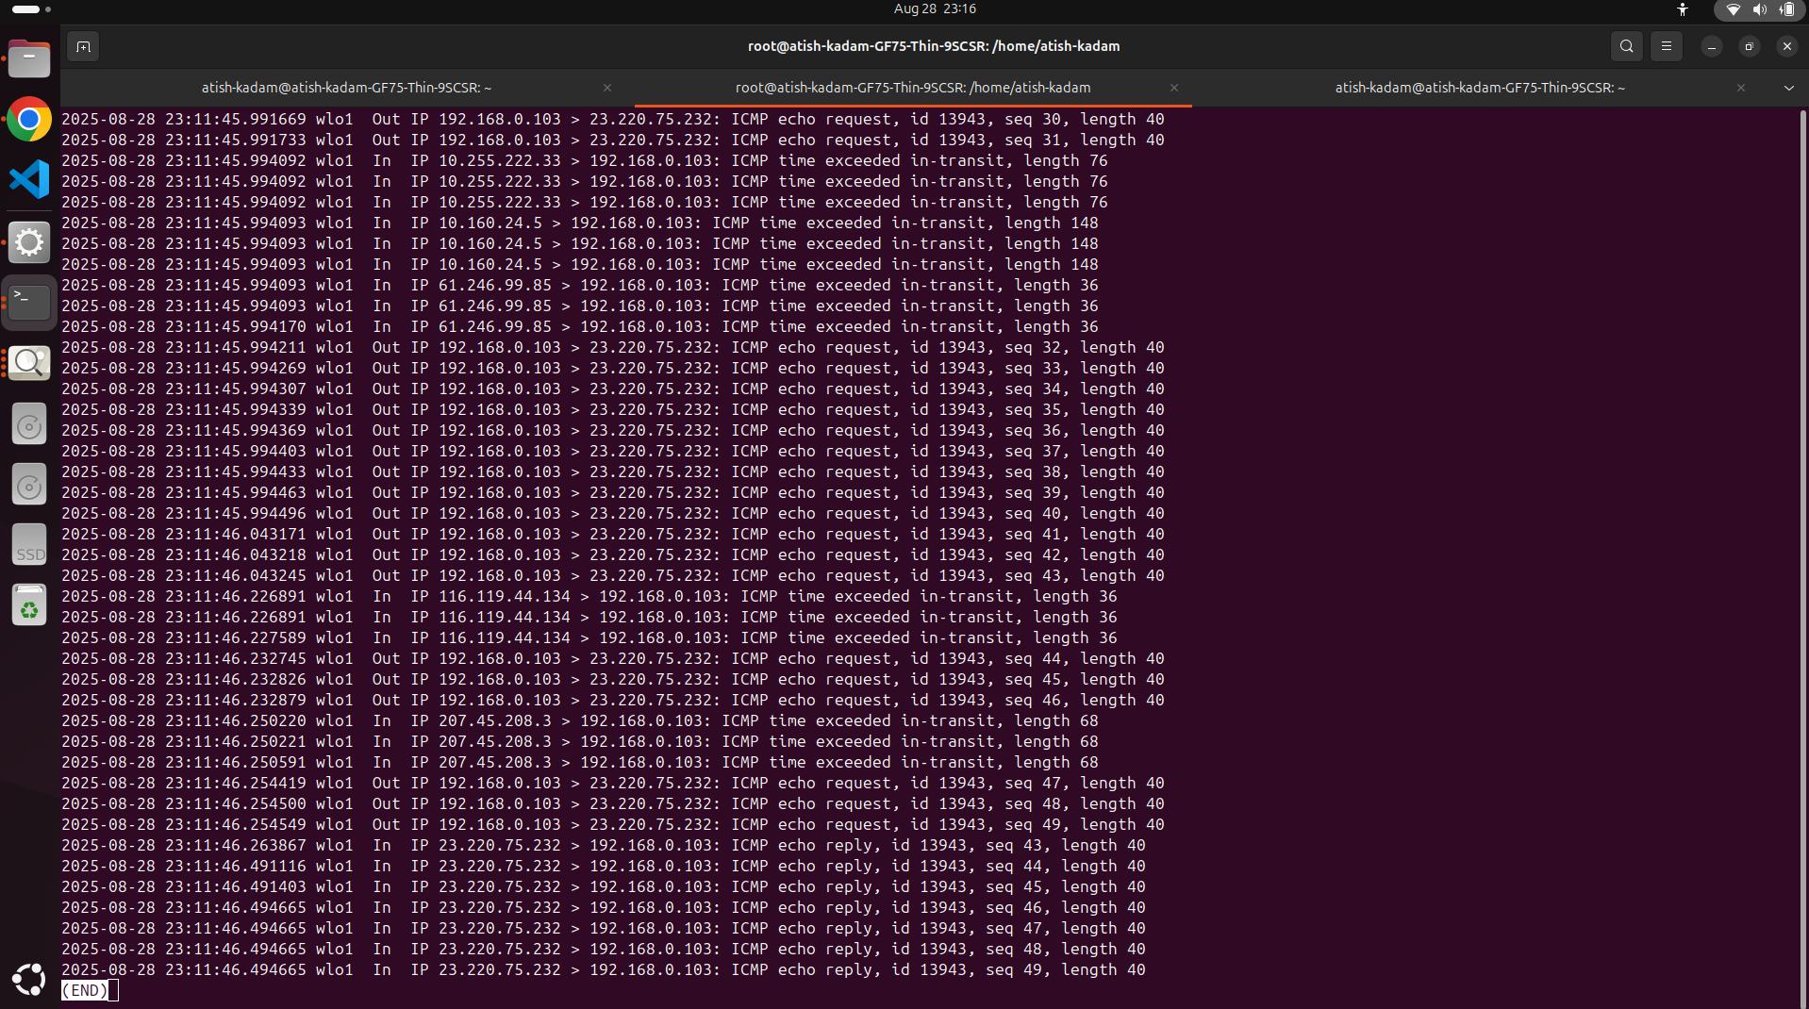
Question - 6
Time for output session = 46.494665- 45.983575=0.51109

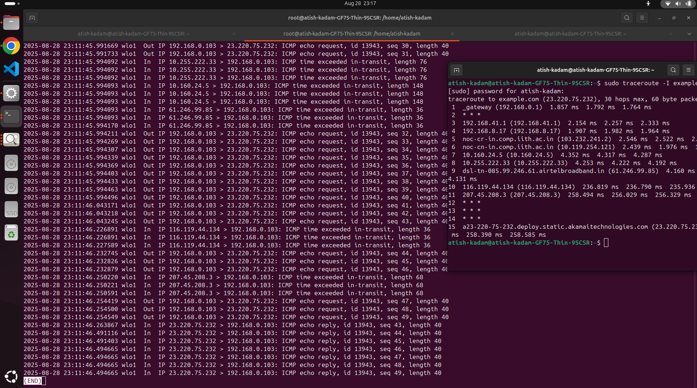
Bottle Neck Router - 116.119.44.134

Question - 8
3 Probe packets are sent per burst
To keep the output concise and relevant, I used the following tcpdump options:
Disables DNS lookups (-n)
Captures only N packets (-c N)
Protocol filters (icmp, tcp, udp) : Limits capture to specific traffic types
Shows time differences between packets for response timing analysis (-ttt / -tttt)
For further refinement, I added:
-i any: Captures packets on all available interfaces
-s0: Captures the entire packet (not just headers)
Protocol-specific filters : Focuses on the relevant protocol for better clarity

